# Sussex Area Community Foundation Inc.

Fall 2014

**Community Connections**

Inside this issue:

## 

SACFI Gala Dinner 2014 1

Random Act of Kindness 1

Scholarships Awarded 2

Matching Program 2

**SACFI Gala Dinner 2014**

In the luxurious setting of Kingswood University's Wesley Hall, over one hundred people from Sussex and surrounding communities, gathered at a Gala Dinner to celebrate the tenth anniversary of the Sussex Area Community Foundation (SACFI).

Keynote Speaker for the evening was Marvi Ricker, Vice President and Man-aging Director of Philan-thropic Services, Bank of Montreal, Harris Private Banking. Ms. Ricker discussed how philan-thropy differs from a char-itable donation. Today’s philanthropists are more concerned with leaving a legacy of giving and are much more interested in knowing exactly where their money is going and how it is being used to effect social change. This is a contrast from the 1950's, when most Canadians were simply charitable donors, who gave money but were not necessarily considering how it was used.

Richard Sullivan, former Chair of SACFI, gave a history of our local Community Foundation and encouraged guests to note in their table brochure the many good works the Foundation had sponsored over the last ten years, with 151 grants to local community groups, 75 student scholarships and 17 Random Act of Kindness grants given to local schools. This money for grants and scholarships is obtained from investment dividends, with the principal left invested.

The dinner was sponsored by Bank of Montreal, Harris Private Banking and guests were invited to consider making their own philanthropic donations to the Foundation, or to recommend to others the value of giving to this worthwhile local community cause through bequests or donations. All donations to the Sussex Area Community Foundation will be issued a tax deductible receipt.

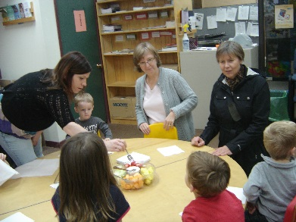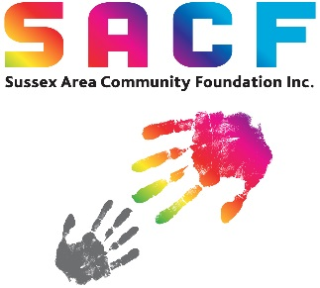

### **Random Act of Kindness**

In 2012 the Sussex Area Community Foundation spearheaded Random Act of Kindness Day (RAK) in Sussex. This is a day to do something kind for someone with nothing in return.

This year, on November 7th, the Sussex Area Community Foundation joined with Sobeys and CJCW to offer grants, Sobeys gift cards and coupons to eight local schools so students could participate in kindness on this day.

CJCW donated air-time to promote and hold Random Act of Kindness draws for Sobeys gift cards and store coupons.

The directors of SACFI dropped by eight local not-for-profits with Sobeys fruit trays as a “thanks” for what you do for our community.

*Thanks to Sobeys and CJCW for supporting RAK in our communities on November 7th.*

For more information or to make a tax deductible donation, please contact

Miriam Verschoor at SACFI.

(506)433-6244

[sacfi@nb.aibn.com](mailto:sacfi@nb.aibn.com)

[www.sacfi.org](http://www.sacfi.org)

Office Hours:

Monday 10-1

Wednesdays 10-1

Join us on FaceBook



SACFI Newsletter Fall 2014

Page 2

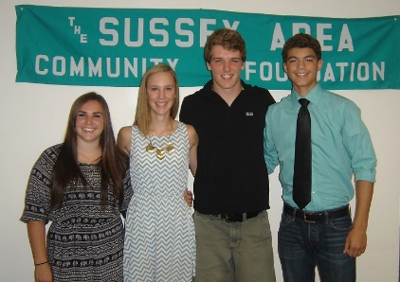

### **Scholarships Awarded**

On Wednesday, August 13, the Sussex Area Community Foundation (SACFI) Directors hosted a Scholars Reception to celebrate the success of the recipients of scholarships given or administered by SACFI.

The Frances Simpson Memorial Scholarship is administered by SACFI and awarded by the family of the late Frances Simpson. The 2014 recipients were: Kristen VanderLaan of Belleisle Regional High School; Rhonda Prosser of Peticodiac Regional High School; and Andrew Hornbrook from Sussex Regional High School.

Five Sussex Area Community Foundation Scholarships of $2500 are awarded yearly to SRHS graduates and the 2014 recipients were: Jacob Freeze; Josiah Gosman; Marty McKenna; Bregha McPhee; and Cora Sharp.

The Earl J. Cunningham Memorial Scholarship is awarded yearly to deserving students and the 2014 recipients were: Matthew Clement who is attending NBCC Moncton and Hilary Pearson who is attending Mount Allison University.

*Photo of SACFI Scholarship recipients Breagha McPhee, Cora Sharp, Marty McKenna and Josiah Gosman.*

**Donations**

Any donations to the SACFI will remain in our community. We accept the following:

•Outright Gift

•Appreciated Security

•Bequest

•Life Insurance

•Charitable Remainder Trust

For more information contact Miriam Verschoor or [sacfi@nb.aibn.com](mailto:sacfi@nb.aibn.com)

Sussex Elementary School new student playground 2013

Be

Use this form to support Sussex area

Name: ______________________________________________

Address: ____________________________________________

City: ___________________ Postal Code: ____________________

Telephone: _______________ Email: _______________________

🞏Enclosed is my gift of $______ 🞏 Please contact me to discuss giving options.

Income tax receipts will be issued for all donations.

Mail to: SACFI 1-494 Main Street, Sussex, NB, E4E 2S4

Sussex Area Community

Kim Pearson has been a volunteer director of Sussex Area Community Foundation since 2012. As a Financial Advisor for Sun Life Financial in Sussex, Kim applied for the Sun Life Volunteer Program where her company will match employee volunteer hours with a donation. As a result, Sun Life donated $500 to SACFI.

Thanks Kim for volunteer-ing and thinking of SACFI with your employer matching program!

Other organizations in the Sussex Area offer matching programs where donations are matched by the employer. Check with the human resources staff of your office to see if your employer can match your donations. It is a great way to increase the benefits to your community and contribute to a great cause. SACFI is also able to receive monthly donations and issue income tax receipts. Please contact Miriam Verschoor at 433-6244 for more information.

### **Employer Matching Program**

Sussex Area Community Foundation Directors:

Grant Beckingham

Fred Brenan

Peter Davidson

Kelly Dunfield

Deborah Freeze

Al Gerrish

Anthony Habraken

Gale Jeffrey

Kim Pearson

Gordon Phillips

Deborah Sellars

Jerry Streisel

Allen Tapley

Scott Walker

**My Gift to the Community** 