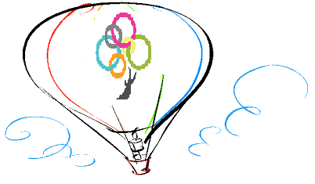
Kindness
Random Act of Kindness Day
Smile at someone Walk a dog Forgive Mistakes
Listen to your heart Let another go first
Pick up litter Open a door Help carry a load
Leave a thank you note Give a compliment
Share your pen Celebrate something good
Do a favor Bake cookies to share Lend a hand
Donate gently used items Encourage a friend
Plant a tree Open a door Offer your seat
Cheer up a friend Use a reusable water Bottle
Make a new friend Say ‘Hello’ Be tolerant
Return a shopping cart for someone
Give a compliment Thank a teacher Read to a child
Share a snack Offer your seat Visit a sick friend
1 November 2019
Sussex Area Community Foundation www.sacfi.org
Thanks to our sponsors above:

