www.sacfi.org | 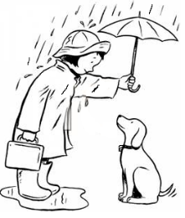  Sussex Area Community Foundation announces:  Random Act of Kindness Day  1 November 2019
www.sacfi.org | Sussex Area Community Foundation announces:  Random Act of Kindness  1 November 2019
www.sacfi.org | Sussex Area Community Foundation announces:  You have been treated to a . . .  Random Act of Kindness  Pay it forward !
www.sacfi.org | Sussex Area Community Foundation announces:  You have been treated to a . . .  Random Act of Kindness  Pay it forward !
www.sacfi.org | Sussex Area Community Foundation announces:  You have been treated to a . . .  Random Act of Kindness  Pay it forward !
Thank you to our sponsors: |  | Share a smile Walk a dog Let Another go first  Read to a child Be tolerant  Offer your seat  Give a compliment  Pick up Litter Plant a tree  Help carry a load  Visit a friend
Thank you to our sponsors: |  | Share a smile Walk a dog Let Another go first  Read to a child Be tolerant  Offer your seat  Give a compliment  Pick up Litter Plant a tree  Help carry a load  Visit a friend
Thank you to our sponsors: |  | Share a smile Walk a dog Let Another go first  Read to a child Be tolerant  Offer your seat  Give a compliment  Pick up Litter Plant a tree  Help carry a load  Visit a friend
Thank you to our sponsors: |  | Share a smile Walk a dog Let Another go first  Read to a child Be tolerant  Offer your seat  Give a compliment  Pick up Litter Plant a tree  Help carry a load  Visit a friend
Thank you to our sponsors: |  | Share a smile Walk a dog Let Another go first  Read to a child Be tolerant  Offer your seat  Give a compliment  Pick up Litter Plant a tree  Help carry a load  Visit a friend

